**$1.00 OFF ANY SIZE PIZZA**

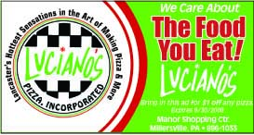

We CARE about the FOOD YOU EAT

**Buy one PIZZA and get $3.00 OFF on SECOND PIZZA**



We CARE about the FOOD YOU EAT

**Buy One PASTA DINNER and get $3.00 the SECOND DINNER**

